**Create Schema for DB**

CREATE SCHEMA `bookmyshow` ;

**Create Movie Table**

CREATE TABLE `movie_list` (

`movieID` int NOT NULL AUTO_INCREMENT,

`movie_name` varchar(45) DEFAULT NULL,

`starCast` varchar(45) DEFAULT NULL,

PRIMARY KEY (`movieID`));

**Table DDL**

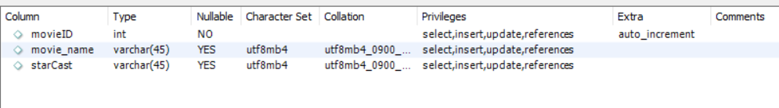

**Table Sample Data**

INSERT INTO `bookmyshow`.`movie_list` (`movie_name`, `starCast`) VALUES ('Su From So', 'Ravi Suma');

INSERT INTO `bookmyshow`.`movie_list` (`movie_name`, `starCast`) VALUES ('War2', 'HR Jnr NTR');

INSERT INTO `bookmyshow`.`movie_list` (`movie_name`, `starCast`) VALUES ('Coolie', 'Rajanikant');

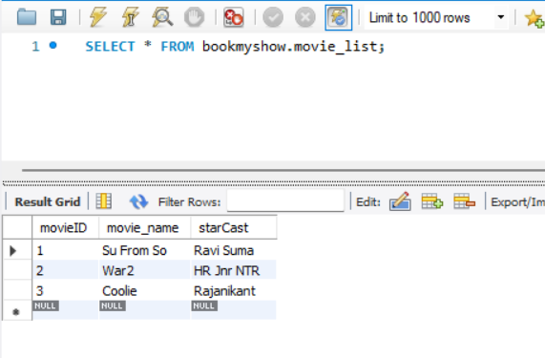

**Create Theatre Table**

CREATE TABLE `theatre_list` (

`theatreID` int NOT NULL AUTO_INCREMENT,

`TheatreName` varchar(50) DEFAULT NULL,

`TheatreAddress` varchar(150) DEFAULT NULL,

PRIMARY KEY (`theatreID`));

**Table DDL**



**Sample Table Data**

INSERT INTO `bookmyshow`.`theatre_list` (`TheatreName`, `TheatreAddress`) VALUES ('PVR', 'Jayanagar');

INSERT INTO `bookmyshow`.`theatre_list` (`TheatreName`, `TheatreAddress`) VALUES ('INOX', 'Koramangala');

INSERT INTO `bookmyshow`.`theatre_list` (`TheatreName`, `TheatreAddress`) VALUES ('Kamakya', 'Ittamadu');

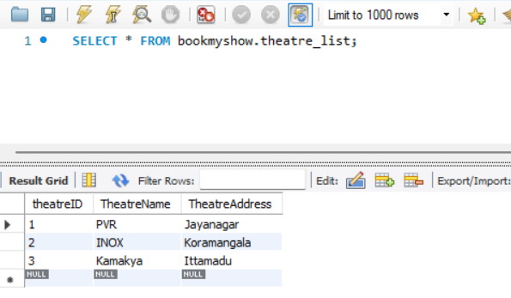

**Create Table Show_List**

CREATE TABLE `bookmyshow`.`show_list` (

`showID` INT NOT NULL AUTO_INCREMENT,

`show_name` VARCHAR(45) NOT NULL,

`show_timings` VARCHAR(45) NOT NULL,

PRIMARY KEY (`showID`));

**DDL**

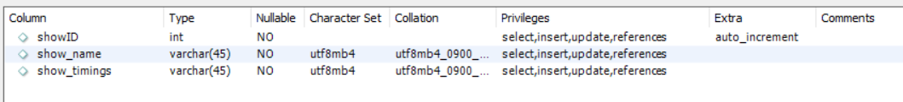

**Sample Data**

INSERT INTO `bookmyshow`.`show_list` (`show_name`, `show_timings`) VALUES ('Morning', '12-15');

INSERT INTO `bookmyshow`.`show_list` (`show_name`, `show_timings`) VALUES ('Matinee', '15-18');

INSERT INTO `bookmyshow`.`show_list` (`show_name`, `show_timings`) VALUES ('Evening', '18-21');

INSERT INTO `bookmyshow`.`show_list` (`show_name`, `show_timings`) VALUES ('Niight', '21-00');

INSERT INTO `bookmyshow`.`show_list` (`show_name`, `show_timings`) VALUES ('Midnight', '00-03');

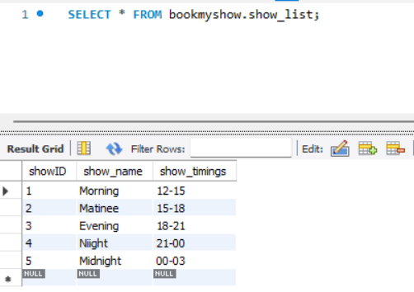

**Create Movie Show Table**

CREATE TABLE `movie_shows` (

`movieShowID` int NOT NULL AUTO_INCREMENT,

`show_Date` date DEFAULT NULL, `theatreID` int DEFAULT NULL,

`movieID` int DEFAULT NULL, `showID` int DEFAULT NULL,

PRIMARY KEY (`movieShowID`), KEY `theatreID_idx` (`theatreID`),

KEY `movieID_idx` (`movieID`), KEY `showID_idx` (`movieShowID`),

KEY `showID_idx1` (`showID`), CONSTRAINT `movieID` FOREIGN KEY (`movieID`) REFERENCES `movie_list` (`movieID`),

CONSTRAINT `showID` FOREIGN KEY (`showID`) REFERENCES `show_list` (`showID`),

CONSTRAINT `theatreID` FOREIGN KEY (`theatreID`) REFERENCES `theatre_list` (`theatreID`));

**DDL**

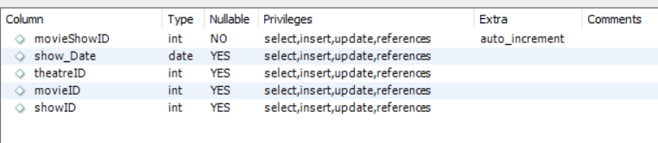

**Sample Data**

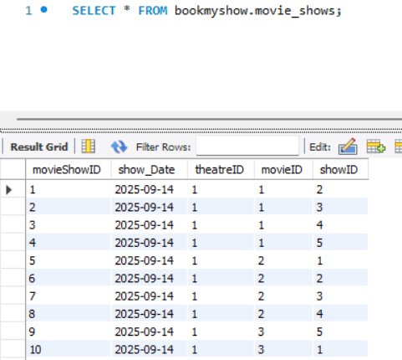

INSERT INTO movie_shows (`movieShowID`,`showDateTime`,`theatreID`,`movieID`,`showID`) VALUES (1,'2025-09-14',1,1,2);

INSERT INTO movie_shows (`movieShowID`,`showDateTime`,`theatreID`,`movieID`,`showID`) VALUES (2,'2025-09-14',1,1,3);

INSERT INTO movie_shows (`movieShowID`,`showDateTime`,`theatreID`,`movieID`,`showID`) VALUES (3,'2025-09-14',1,1,4);

INSERT INTO movie_shows (`movieShowID`,`showDateTime`,`theatreID`,`movieID`,`showID`) VALUES (4,'2025-09-14',1,1,5);

INSERT INTO movie_shows (`movieShowID`,`showDateTime`,`theatreID`,`movieID`,`showID`) VALUES (5,'2025-09-14',1,2,1);

INSERT INTO movie_shows (`movieShowID`,`showDateTime`,`theatreID`,`movieID`,`showID`) VALUES (6,'2025-09-14',1,2,2);

INSERT INTO movie_shows (`movieShowID`,`showDateTime`,`theatreID`,`movieID`,`showID`) VALUES (7,'2025-09-14',1,2,3);

INSERT INTO movie_shows (`movieShowID`,`showDateTime`,`theatreID`,`movieID`,`showID`) VALUES (8,'2025-09-14',1,2,4);

INSERT INTO movie_shows (`movieShowID`,`showDateTime`,`theatreID`,`movieID`,`showID`) VALUES (9,'2025-09-14',1,3,5);

INSERT INTO movie_shows (`movieShowID`,`showDateTime`,`theatreID`,`movieID`,`showID`) VALUES (10,'2025-09-14',1,3,1);

INSERT INTO movie_shows (`movieShowID`,`showDateTime`,`theatreID`,`movieID`,`showID`) VALUES (11,'2025-09-14',1,3,2);

INSERT INTO movie_shows (`movieShowID`,`showDateTime`,`theatreID`,`movieID`,`showID`) VALUES (12,'2025-09-14',1,3,3);

INSERT INTO movie_shows (`movieShowID`,`showDateTime`,`theatreID`,`movieID`,`showID`) VALUES (13,'2025-09-14',2,1,4);

INSERT INTO movie_shows (`movieShowID`,`showDateTime`,`theatreID`,`movieID`,`showID`) VALUES (14,'2025-09-14',2,1,5);

INSERT INTO movie_shows (`movieShowID`,`showDateTime`,`theatreID`,`movieID`,`showID`) VALUES (15,'2025-09-14',2,1,1);

INSERT INTO movie_shows (`movieShowID`,`showDateTime`,`theatreID`,`movieID`,`showID`) VALUES (16,'2025-09-14',2,1,2);

INSERT INTO movie_shows (`movieShowID`,`showDateTime`,`theatreID`,`movieID`,`showID`) VALUES (17,'2025-09-14',2,2,3);

INSERT INTO movie_shows (`movieShowID`,`showDateTime`,`theatreID`,`movieID`,`showID`) VALUES (18,'2025-09-14',2,2,4);

INSERT INTO movie_shows (`movieShowID`,`showDateTime`,`theatreID`,`movieID`,`showID`) VALUES (19,'2025-09-14',2,2,5);

INSERT INTO movie_shows (`movieShowID`,`showDateTime`,`theatreID`,`movieID`,`showID`) VALUES (20,'2025-09-14',2,2,1);

INSERT INTO movie_shows (`movieShowID`,`showDateTime`,`theatreID`,`movieID`,`showID`) VALUES (21,'2025-09-14',2,3,2);

INSERT INTO movie_shows (`movieShowID`,`showDateTime`,`theatreID`,`movieID`,`showID`) VALUES (22,'2025-09-14',2,3,3);

INSERT INTO movie_shows (`movieShowID`,`showDateTime`,`theatreID`,`movieID`,`showID`) VALUES (23,'2025-09-14',2,3,4);

INSERT INTO movie_shows (`movieShowID`,`showDateTime`,`theatreID`,`movieID`,`showID`) VALUES (24,'2025-09-14',2,3,5);

INSERT INTO movie_shows (`movieShowID`,`showDateTime`,`theatreID`,`movieID`,`showID`) VALUES (25,'2025-09-14',3,1,1);

INSERT INTO movie_shows (`movieShowID`,`showDateTime`,`theatreID`,`movieID`,`showID`) VALUES (26,'2025-09-14',3,1,2);

INSERT INTO movie_shows (`movieShowID`,`showDateTime`,`theatreID`,`movieID`,`showID`) VALUES (27,'2025-09-14',3,1,3);

INSERT INTO movie_shows (`movieShowID`,`showDateTime`,`theatreID`,`movieID`,`showID`) VALUES (28,'2025-09-14',3,1,4);

INSERT INTO movie_shows (`movieShowID`,`showDateTime`,`theatreID`,`movieID`,`showID`) VALUES (29,'2025-09-14',3,2,5);

INSERT INTO movie_shows (`movieShowID`,`showDateTime`,`theatreID`,`movieID`,`showID`) VALUES (30,'2025-09-14',3,2,1);

INSERT INTO movie_shows (`movieShowID`,`showDateTime`,`theatreID`,`movieID`,`showID`) VALUES (31,'2025-09-14',3,2,2);

INSERT INTO movie_shows (`movieShowID`,`showDateTime`,`theatreID`,`movieID`,`showID`) VALUES (32,'2025-09-14',3,2,3);

INSERT INTO movie_shows (`movieShowID`,`showDateTime`,`theatreID`,`movieID`,`showID`) VALUES (33,'2025-09-14',3,3,4);

INSERT INTO movie_shows (`movieShowID`,`showDateTime`,`theatreID`,`movieID`,`showID`) VALUES (34,'2025-09-14',3,3,5);

INSERT INTO movie_shows (`movieShowID`,`showDateTime`,`theatreID`,`movieID`,`showID`) VALUES (35,'2025-09-14',3,3,1);

INSERT INTO movie_shows (`movieShowID`,`showDateTime`,`theatreID`,`movieID`,`showID`) VALUES (36,'2025-09-14',3,3,2);

INSERT INTO movie_shows (`movieShowID`,`showDateTime`,`theatreID`,`movieID`,`showID`) VALUES (37,'2025-09-15',1,1,3);

INSERT INTO movie_shows (`movieShowID`,`showDateTime`,`theatreID`,`movieID`,`showID`) VALUES (38,'2025-09-15',1,1,4);

INSERT INTO movie_shows (`movieShowID`,`showDateTime`,`theatreID`,`movieID`,`showID`) VALUES (39,'2025-09-15',1,1,5);

INSERT INTO movie_shows (`movieShowID`,`showDateTime`,`theatreID`,`movieID`,`showID`) VALUES (40,'2025-09-15',1,1,1);

INSERT INTO movie_shows (`movieShowID`,`showDateTime`,`theatreID`,`movieID`,`showID`) VALUES (41,'2025-09-15',1,2,2);

INSERT INTO movie_shows (`movieShowID`,`showDateTime`,`theatreID`,`movieID`,`showID`) VALUES (42,'2025-09-15',1,2,3);

INSERT INTO movie_shows (`movieShowID`,`showDateTime`,`theatreID`,`movieID`,`showID`) VALUES (43,'2025-09-15',1,2,4);

INSERT INTO movie_shows (`movieShowID`,`showDateTime`,`theatreID`,`movieID`,`showID`) VALUES (44,'2025-09-15',1,2,5);

INSERT INTO movie_shows (`movieShowID`,`showDateTime`,`theatreID`,`movieID`,`showID`) VALUES (45,'2025-09-15',1,3,1);

INSERT INTO movie_shows (`movieShowID`,`showDateTime`,`theatreID`,`movieID`,`showID`) VALUES (46,'2025-09-15',1,3,2);

INSERT INTO movie_shows (`movieShowID`,`showDateTime`,`theatreID`,`movieID`,`showID`) VALUES (47,'2025-09-15',1,3,3);

INSERT INTO movie_shows (`movieShowID`,`showDateTime`,`theatreID`,`movieID`,`showID`) VALUES (48,'2025-09-15',1,3,4);

INSERT INTO movie_shows (`movieShowID`,`showDateTime`,`theatreID`,`movieID`,`showID`) VALUES (49,'2025-09-15',2,1,5);

INSERT INTO movie_shows (`movieShowID`,`showDateTime`,`theatreID`,`movieID`,`showID`) VALUES (50,'2025-09-15',2,1,1);

INSERT INTO movie_shows (`movieShowID`,`showDateTime`,`theatreID`,`movieID`,`showID`) VALUES (51,'2025-09-15',2,1,2);

INSERT INTO movie_shows (`movieShowID`,`showDateTime`,`theatreID`,`movieID`,`showID`) VALUES (52,'2025-09-15',2,1,3);

INSERT INTO movie_shows (`movieShowID`,`showDateTime`,`theatreID`,`movieID`,`showID`) VALUES (53,'2025-09-15',2,2,4);

INSERT INTO movie_shows (`movieShowID`,`showDateTime`,`theatreID`,`movieID`,`showID`) VALUES (54,'2025-09-15',2,2,5);

**Final Query and Output**

SELECT t.theatreName, m.movie_name, show_name, show_Date, show_timings

FROM bookmyshow.movie_shows s

join bookmyshow.movie_list m on s.movieID = m.movieID

join bookmyshow.theatre_list t on t.theatreID = s.theatreID

join bookmyshow.show_list l on s.showID = l.showID

where t.theatreName = 'PVR' and show_Date = '2025-09-14'

order by m.movie_name, show_Date, show_timings;

